PRICE LIST – ALL INDIA (w.e.f.1st January.2014)
EDUCATIONAL PUBLISHING HOUSE
(candles and fragrance section)
3108,VAKIL STREET, KUCHA PANDIT, LAL KUAN, DELHI – 110006
PH.: (91-11)23214465, 23216162 , FAX: 23211540 , MOB. 9899622725
E-mail: ephindia@gmail.com ; Website: www.ephbooks.com

Picture |  | Dim.  (MM) | Product name/code |  | Pcs./  pkt.  (Nos) | Rate/  pkt.  (Rs.) |  | Pkts./  Ctn.  (Nos.) | Price/  Carton  (Rs.) | Light hrs.
 |  | Dia. Ht. |  | Floating Candle
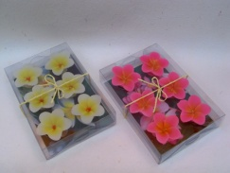 |  |  | CC-1324 |  | 6 | 70Rs. |  | 100 |  | 1.5
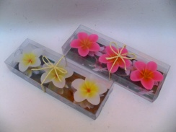 |  |  | CC-1323 |  | 6 | 70Rs. |  | 100 |  | 1.5
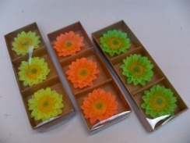 |  |  | C14-04 |  | 6 | 70Rs. |  | 100 |  | 1.5
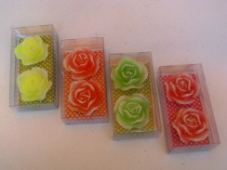 |  |  | FFC-101(A) |  | 2 | 40Rs. |  | 100 |  | 1.5
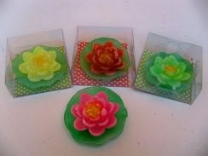 |  |  | C14-03 |  | 1 | 30Rs. |  | 100 |  | 1.5
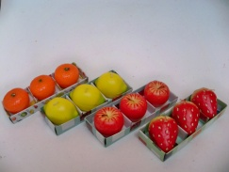 |  |  | Fruits |  | 3 | 90Rs. |  | 100 |  | 1.5
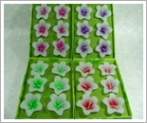 |  | 49 23 | FFC-101(A) |  | 6 | 50Rs. |  | 96 |  | 1.5
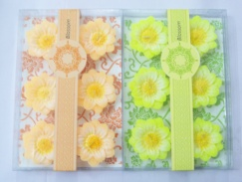 12:grams |  | 52 25 | FFC-101(B) |  | 6 | 60Rs. |  | 96 |  | 1.5
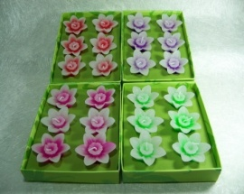  11:grams |  | 50 23 | FFC-101(C) |  | 6 | 60Rs. |  | 96 |  | 1.5
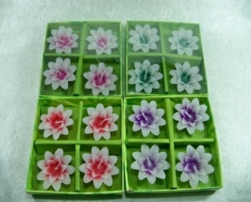  13:grams |  | 55 24 | FFC-102(B) |  | 4 | 60Rs. |  | 96
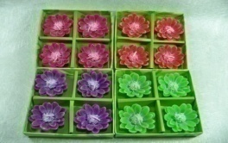  16:grams |  | 59 23 | FFC-102(C) |  | 4 | 60Rs. |  | 96
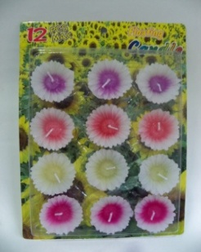 |  |  | FFC-107 |  | 12 | 50Rs. |  | 120 |  | 0.5
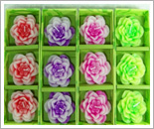 |  | 63 27 | FFC-103(A) |  | 3 | 70 Rs. |  | 96 |  | 2
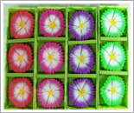 |  | 65 27 | FFC-103(B) |  | 3 | 70 Rs. |  | 96 |  | 2
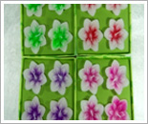 |  | 66 27 | FFC-104(C) |  | 4 | 75 Rs. |  | 96 |  | 2
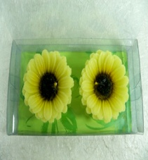 |  | 77 37 | FFC-105 |  | 2 | 75 Rs. |  | 96 |  | 2
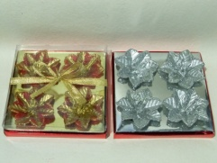 |  |  | GS-04 |  | 4 | 80 | 48 | 96
 | Handmade Floating Candle
Picture |  | Dim.  (MM) | Product name/code |  | Pcs.  (Nos) | Rate/  pkt.  (Rs.) |  | Pkts./  Ctn.  (Nos.) | Price/  Carton  (Rs.) | Light hrs.
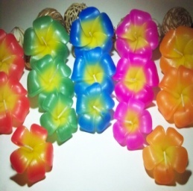 |  | (6x6x3)cm.  (7.5x7.5x4)cm.  (9x9x4)cm. | PLUMERIA  CNF-01S  CNF-01M  CNF-01L |  | 1  1  1 | S 30  M 40  L 70 |  |  |  | S 1  M 1.5  L 1.5
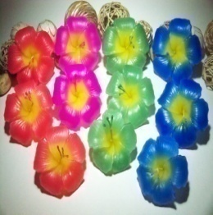 |  | (6x6x3)cm.  (7.5x7.5x4)cm.  (9x9x4)cm. | HBISCUS  CNF-02S  CNF-02M  CNF-02L |  | 1  1  1 | S 30  M 45  L 75 |  |  |  | S 1  M 1.5  L 1.5
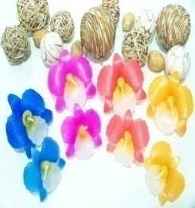 |  | (6x6x3)cm.  (7.5x7.5x4)cm. | ORCHID  CNF-03S  CNF-03M |  | 1  1  1 | S 30  M 45 |  |  |  | S 1  M 2
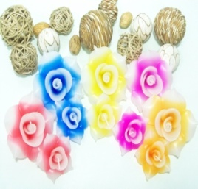 |  | (6x6x3.5)cm  (9.5x9.5x4)cm. | Rose  CNF-04S  CNF-04L |  | 1  1 | S 30  L 75 |  |  |  | S 1.5  L 3
Picture |  | Dim.  (MM) | Product name/code |  | Pcs./  pkt.  (Nos) | Rate/  pkt.  (Rs.) |  | Pkts./  Ctn.  (Nos.) | Price/  Carton  (Rs.) | Light hrs.
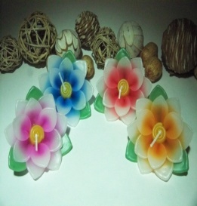 |  | (8.5x8.5x3.5)cm. | LOTUS  CNF-05 |  | 1 | 45 |  |  |  | 1.5
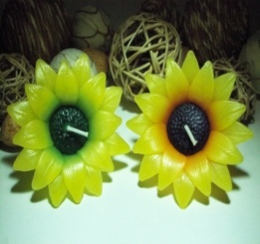 |  | (8x8x3.5)cm. | SUN FLOWER  CNF-06 |  | 1 | 75 |  |  |  | 2
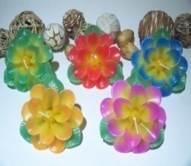 |  | (8.5x8.5x3.5)cm. | DAISY  CNF-07 |  | 1 | 50 |  |  |  | 2
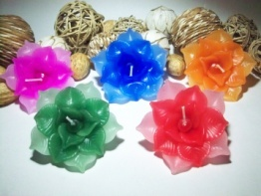 |  | (8.5x8.5x3.5)cm. | LOTUS  CNF-08 |  | 1 | 50 |  |  |  | 1.5
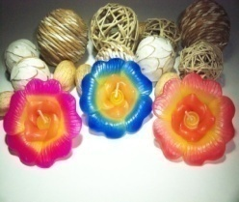 |  | (8.5x8.5x3.5)cm. | HIBISCUS  CNF-09 |  | 1 | 45 |  |  |  | 1.5
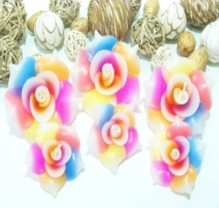 |  | (6.5x6.5x3.5)cm.  (9.5x9.5x4)cm. | MULTICOLOR ROSE  CNF-10S  CNF-10L |  | 1  1 | S 45  L 75 |  |  |  | S 1.5  L 3
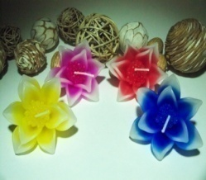 |  |  | CNF-11 |  | 1 | 45
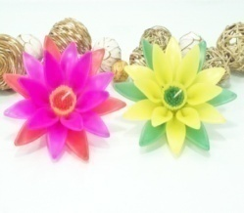 |  |  | BIG LOTUS  CNF-12L |  | 1 | 250 |  |  |  | 3
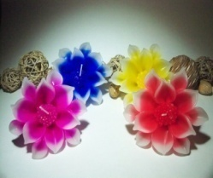 |  |  | CNF-13L |  | 1 | 250 |  |  |  | 3
Picture |  | Dim.  (INCH) | Product name/code |  | Pcs./  pkt.  (Nos) | Rate/  pkt.  (Rs.) |  | Pkts./  Ctn.  (Nos.) | Price/  Carton  (Rs.)
 |  | Dia. Ht. |  | PILLAR CANDLE
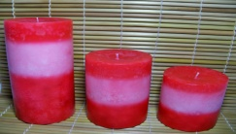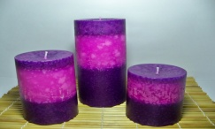 |  | 3” 3”  3” 4”  3” 6” | MOTTLED PILLAR  CNF-401 |  | 1 | 130  180  270 |  | 64
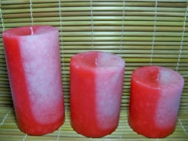 |  | 3” 3”  3” 4”  3” 6” | MOTTLED PILLAR  CNF-402 |  | 1 | 130  180  270 |  | 64
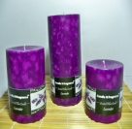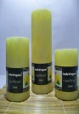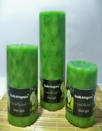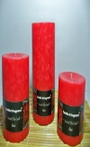 |  | 3” 3”  3” 4”  3” 6” | MOTTLED PILLAR  CNF-403 |  | 1 | 100  150  225 |  | 64
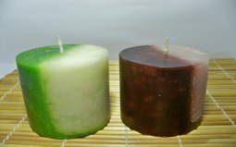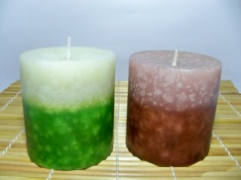 |  | 3” 3”  3” 4”  3” 6”  3” 3” | MOTTLED PILLAR  CNF-405(A)  MOTTLED PILLAR  CNF-405(B) |  | 1 | 130  150  270  130 |  | 64
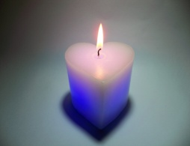 |  |  | CNF-408  Led Heart  3x3’’pillar  3x6’’pillar  3x8’’pillar  3x3’’ ball  3x3’’square |  | 1  1  1  1  1  1 | 200Rs.  200Rs.  240Rs.  330Rs.  175Rs.  240Rs. |  | 36  36  36  36  36  36
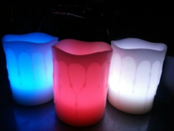  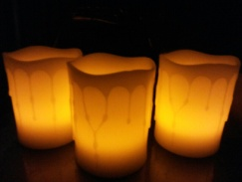 |  |  | LC-04 Color changing |  | 1 | 300Rs. |  | 36

Picture | Product name/code |  | Pcs./  pkt.  (Nos) |  | Rate/  pkt.  (Rs.) |  | Pkts./  Ctn.  (Nos.) |  | Price/  Carton  (Rs.) | Light hrs.
 | PILLAR CANDLE
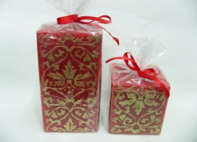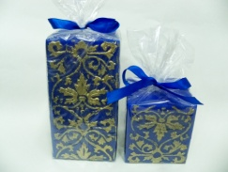 | CNF-06 |  |  |  | 150Rs.  240Rs.
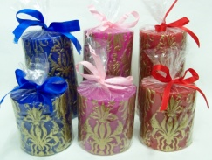 | CNF-07 |  |  |  | 140Rs.  180Rs
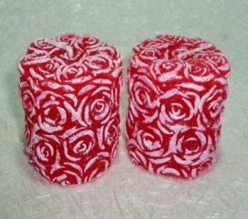 | SNOW LINE  FPC-07 |  | 1 |  | 75Rs. |  | 64
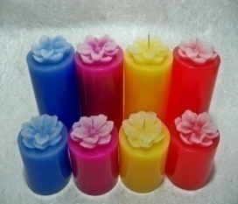 | FLOWER PILLAR FPC-08  Size:(2x4inch)  (2x2inch) |  | 1  1 |  | 75Rs.  40Rs. |  | 96  120
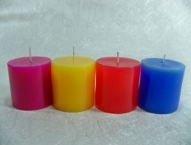 | PLAIN PILLAR  PC-11  (2x2inch) |  | 1 |  | 30Rs. |  | 120
GIFT SETS
Picture | Pcs./  pkt.  (Nos) | Rate/  pkt.  (Rs.) |  | Pkts./  Ctn.  (Nos.) |  | Price/  Carton  (Rs.) |  | Product Code
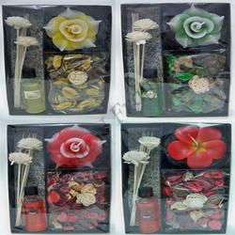 | 5  (candle + reed diffuser+pot pourri) | 250Rs. |  | 32 |  |  |  | CNF-202
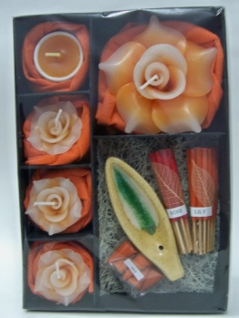 | 9  (candles + aroma perfume sticks) | 250Rs. |  | 32 |  |  |  | CNF-203
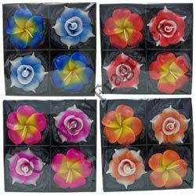 | 4 | 225Rs. |  | 32 |  |  |  | CNF-201
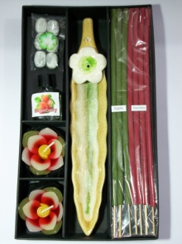 | 6  (candles + aroma perfume sticks) | 225Rs. |  | 32 |  |  |  | CNF-204
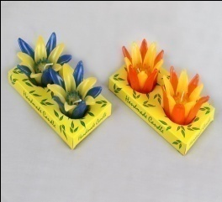 | 2 | 200Rs. |  | 48 |  |  |  | CNF-205
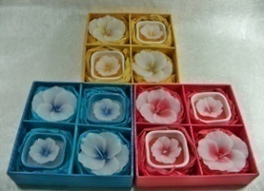 | 4 | 130Rs. |  | 60 |  |  |  | CGS-003
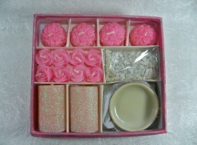 | 16 | 300Rs. |  | 48 |  |  |  | CGS-005
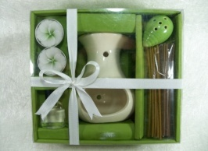 | 6 | 225Rs. |  | 24 |  |  |  | CGS-006
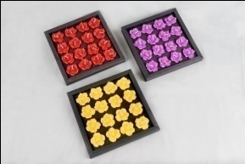 | 16 | 150Rs. |  | 60 |  |  |  | CGS-004  (Most selling)
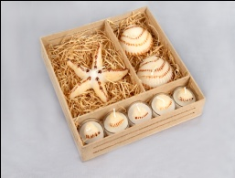 | 8  Star fish | 200Rs. |  | 48 |  |  |  | CGS-001  (best selling)
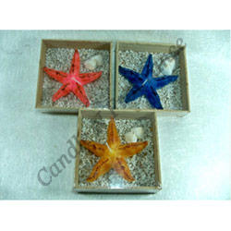 | 1  Star fish | 75Rs. |  | 60 |  |  |  | CGS-002
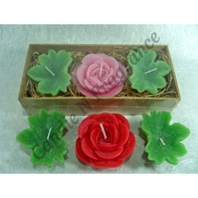 | 3 | 100Rs. |  | 60 |  |  |  | ROSE PLANT  CGS-007
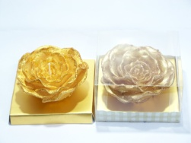 | 1 | 80Rs. |  | 60 |  |  |  | CGS-011
Picture | Product  Weight |  | Pcs./  pkt.  (Nos) |  | Rate/  pkt.  (Rs.) |  | Pkts./  Ctn.  (Nos.) |  | Price/  Carton  (Rs.)
 | Potpourri
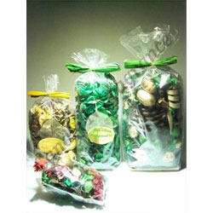 | 30 grams |  | 1 |  | 30Rs.
 | 50 grams |  | 1 |  | 50Rs.
 | 100 grams |  | 1 |  | 70Rs.
 | 200 grams |  | 1 |  | 90RS.
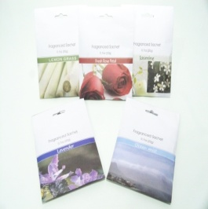 | Sachet  (Lavender,  Jasmine,  Ocean Mist,  Rose,  Lemon grass) |  | 1 |  | 35 Rs. |  |  |  | 17grams

Picture | Dim.  (MM) | Product name/code | Pcs./  pkt.  (Nos) | Rate/  pkt.  (Rs.) | Pkts./  Ctn.  (Nos.) | Price/  Carton  (Rs.) | Light hrs.
 | Dia. Ht. | Tea Light Candle
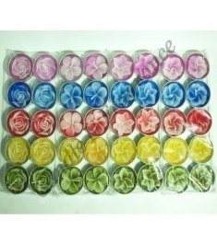 | 38-mm. | TLC-1004 | 10 | 60Rs. | 100 |  | 4hrs.
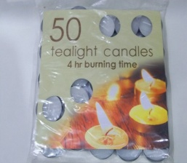 | 38-mm. | TLC-1002 | 50 | 180Rs. | 20 |  | 4hrs.

Picture | Dim.  (MM) | Product name/code | Pcs./  pkt.  (Nos) | Rate/  pkt.  (Rs.) | Pkts./  Ctn.  (Nos.) | Price/  Carton  (Rs.) | Light hrs.
 | Dia. Ht. | Lanterns
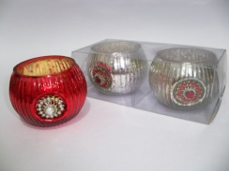 |  | TLCH-503 | 2 | 225Rs. | 30
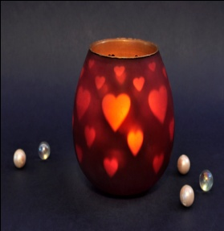 |  | TLCH-502 | 1 | 180Rs. | 27 |  | Branding can be done

Picture | Weight  (ml.) | Product name/code | Pcs./  pkt.  (Nos) | Rate/  pkt.  (Rs.) | Pkts./  Ctn.  (Nos.) | Price/  Carton  (Rs.) | Fragrances
 |  | REED DIFFUSERS
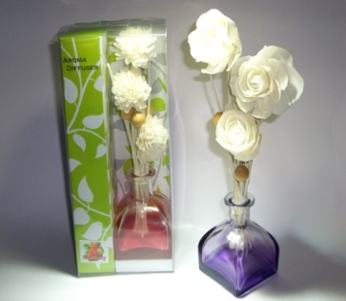 | 100ml. | CNF-102  (Most Selling) | 1 | 350Rs. | 24 |  | Rose  Jasmine  Lavender  Apple  Lemon  Strawberry  Ocean Breeze
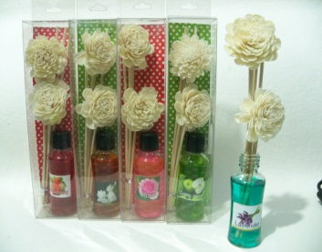 | 30ml.  Reed Diffuser | CNF-103 | 1 | 100Rs. | 60 |  | Rose  Jasmine  Lavender  Apple  Lemon  Strawberry  Ocean Breeze
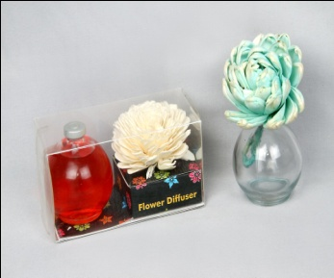 | 100ml.  Flower Diffuser | CNF-104 | 1 | 270Rs. | 36 |  | Rose  Jasmine  Lavender  Apple  Lemon  Strawberry  Ocean Breeze
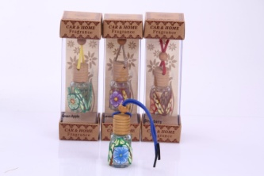 | 10ml.  Car Freshener | CF-01 | 1 | 160Rs. | 24 |  | Rose  Jasmine  Lavender  Apple  Lemon  Strawberry  Ocean Breeze

AROMA LAMP SETS
Picture | Pcs./  pkt.  (Nos) | Rate/  pkt.  (Rs.) | Pkts./  Ctn.  (Nos.) | Price/  Carton  (Rs.) | Product Code
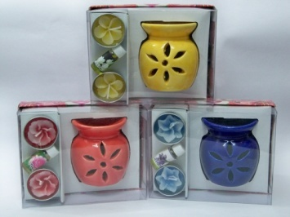 | 4 | 100Rs. | 48 |  | AL-01  (best Selling)
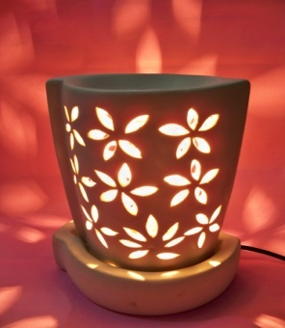 | Size  7 inch | 450Rs. |  |  | Al-375
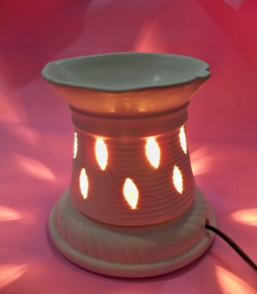 | Size  5inch | 300Rs. |  |  | Al-185
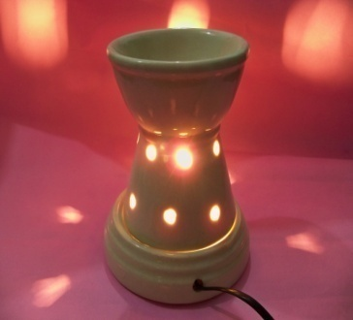 | 1 | 325Rs. |  |  | AL-210
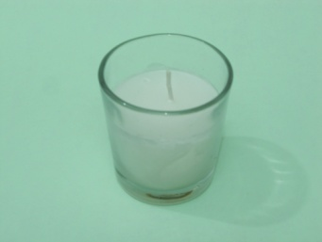 | Weight  50-55grms. | 40Rs. |  |  | V-01
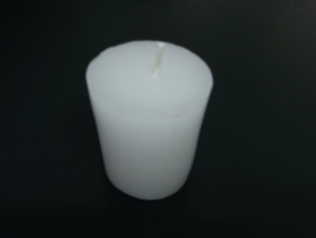 | 1 | 30Rs. |  |  | V-02
HOLLOW CANDLES
Picture | Dim.  (MM) | Product name/code | Pcs./  pkt.  (Nos) | Rate/  pkt.  (Rs.) | Pkts./  Ctn.  (Nos.)
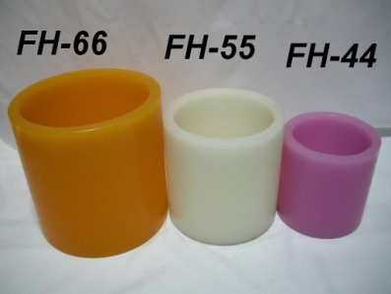 | 4”x4”  4”x6”  4”x8”  5’’x5’’  6’’x6’’ | FH-44  FH-46  FH-48  FH-55  FH-66 |  | 180.00 240.00  270.00  300.00  400.00
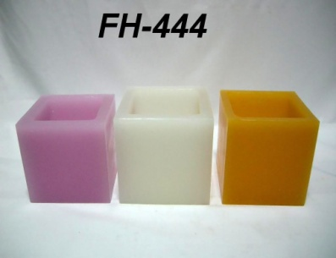 | 4’’x4’’x4’’ | FH-444 |  | 240.00
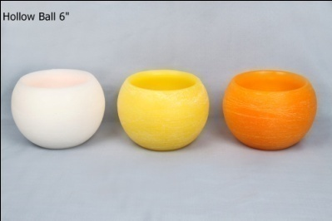 | Ball 6” | FH-6 BL |  | 270.00
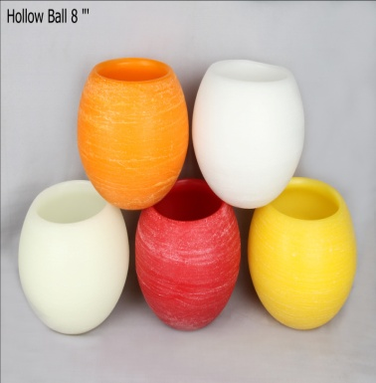 | Ball 8’’  Ball 10’’ | FH-8 BL  FH-10 BL |  | 600.00  1300.00
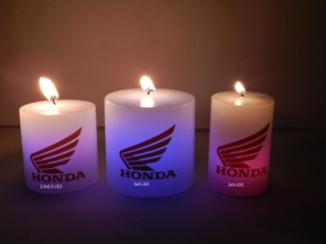 | 3x3’’pillar  3x6’’pillar  3x8’’pillar  3x3’’ ball  3x3’’square | Corporate LED |  | 200Rs.  300Rs.  350Rs.  180Rs.  240Rs. | (best Selling)
PRICE LIST – ALL INDIA (w.e.f.1st January.2013)
Candle N Fragrance
3367, KUCHA PANDIT, AJMERI GATE, DELHI – 110006
PH.: (91-11)23231941/MOB.:+91-9953510705/+9999464041
E-mail: candlenfragrance@yahoo.com ; Website: http://www.indiamart.com/candlenfragrance

Picture | Dim.  (MM) | Product name/code |  | Pcs./  pkt.  (Nos) | Rate/  pkt.  (Rs.) |  | Pkts./  Ctn.  (Nos.) | Price/  Carton  (Rs.) | Light hrs.
 |  |  | Candle Gift Set
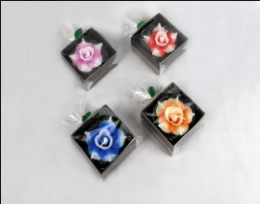 |  | CNF-206A |  | 1 | 90/- |  |  |  | 1.5
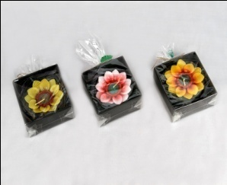 |  | CNF-206B |  | 1 | 90/- |  |  |  | 1.5
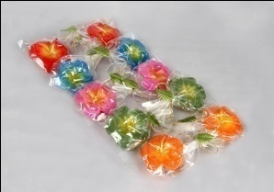 |  | CNF-1 |  | 1 | 200/- |  |  |  | 1.5

